Simple and compound depreciation
As soon as a new car leaves the dealership, its value decreases and it is considered “second-hand”. Vehicles, equipment, machinery and other similar assets, all lose value over time as a result of usage and age. This loss in value is called depreciation. Assets that have a relatively long useful lifetime, such as machines, trucks, farming equipment etc., depreciate slower than assets like office equipment, computers, furniture etc. which need to be replaced more often and therefore depreciate more quickly.
Depreciation is used to calculate the value of a company's assets, which determines how much tax a company must pay. Companies can take depreciation into account as an expense, and thereby reduce their taxable income. A lower taxable income means that the company will pay less income tax to SARS (South African Revenue Service).
We can calculate two different kinds of depreciation: simple decay and compound decay. Decay is also a term used to describe a reduction or decline in value. Simple decay is also called straight-line depreciation and compound decay can also be referred to as reducing-balance depreciation. In the straight-line method the value of the asset is reduced by a constant amount each year, which is calculated on the principal amount. In reducing-balance depreciation we calculate the depreciation on the reduced value of the asset. This means that the value of an asset decreases by a different amount each year.

Activity 1: Investigation: Simple and compound depreciation
- Mr. Sontange buys an Opel Fiesta for R 72 000. He expects that the value of the car will depreciate by R 6000 every year. He draws up a table to calculate the depreciated value of his Opel Fiesta.
Complete Mr. Sontange's table of values for the 7 year period:
Year | Value at beginning of year | Depreciation amount | Value at end of year
1 | R 72 000 | R 6000 | R 66 000
2 | R 66 000 | R 6000
3
4
5
6
7
- His son, David, does not agree that the value of the car will reduce by the same amount each year. David thinks that the car will depreciate by 10% every year.
Complete David's table of values:
Year | Value at beginning of year | Depreciation amount | Value at end of year
1 | R 72 000 | R 7200 | R 64 800
2 | R 64 800 | R 6480
3
4
5
6
7
- Compare and discuss the results of the two different tables.
- Consider the graph below, which represents Mr. Sontange's table of values:
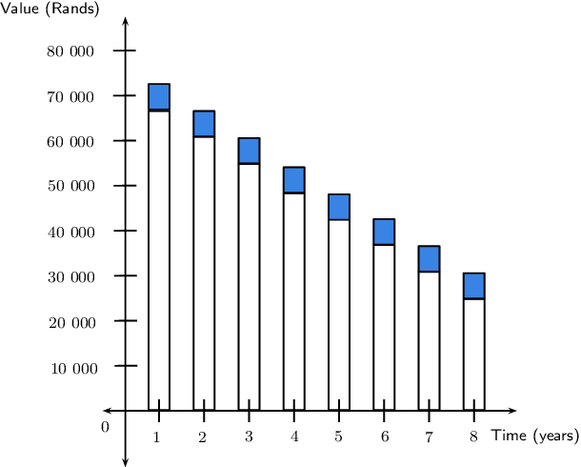
  - Draw a similar graph using David's table of values.
  - Interpret the two graphs and discuss the differences between them.
  - Explain how the graphs can be used to determine the total depreciation in each case.

    - Draw two new graphs by plotting the maximum value of each bar.
    - Join the points with a line to show the general trend.
    - Is it mathematically correct to join these points? Explain your answer.

Simple depreciation

Example 1: Straight-line depreciation

Question
A new smartphone costs R 6000 and depreciates at 22% p.a. on a straight-line basis. Determine the value of the smartphone at the end of each year over a 4 year period.
Show me this worked solution
We notice that
where
Therefore the depreciated value of the asset (also called the book value) can be calculated as:
Note the similarity to the simple interest formula A=P(1+in). Interest increases the value of the principal amount, whereas with simple decay, depreciation reduces the value of the principal amount.
Important: to get an accurate answer do all calculations in one step on your calculator. Do not round off answers in your calculations until the final answer. In the worked examples in this chapter, we use dots to show that the answer has not been rounded off. We always round the final answer to two decimal places (cents).

Example 2: Straight-line depreciation method

Question
A car is valued at R 240 000. If it depreciates at 15% p.a. using straight-line depreciation, calculate the value of the car after 5 years.
Show me this worked solution

Example 3: Simple decay

Question
A small business buys a photocopier for R 12 000. For the tax return the owner depreciates this asset over 3 years using a straight-line depreciation method. What amount will he fill in on his tax form at the end of each year?
Show me this worked solution

Exercise 1: Simple decay
Problem 1:
A business buys a truck for R 560 000. Over a period of 10 years the value of the truck depreciates to R 0 using the straight-line method. What is the value of the truck after 8 years?
Show me the answers Practise more questions like this
Problem 2:
Harry wants to buy his grandpa's donkey for R 800. His grandpa is quite pleased with the offer, seeing that it only depreciated at a rate of 3% per year using the straight-line method. Grandpa bought the donkey 5 years ago. What did grandpa pay for the donkey then?
Show me the answers Practise more questions like this
Problem 3:
Seven years ago, Rocco's drum kit cost him R 12 500. It has now been valued at R 2300. What rate of simple depreciation does this represent?
Show me the answers Practise more questions like this
Problem 4:
Fiona buys a DStv satellite dish for R 3000. Due to weathering, its value depreciates simply at 15% per annum. After how long will the satellite dish have a book value of zero?
Show me the answers Practise more questions like this

Compound depreciation

Example 4: Reducing-balance depreciation

Question
A second-hand farm tractor worth R 60 000 has a limited useful life of 5 years and depreciates at 20% p.a. on a reducing-balance basis. Determine the value of the tractor at the end of each year over the 5 year period.
Show me this worked solution
Notice in the example above that we could also write the book value at the end of each year as:
Using the formula for simple decay and the observed pattern in the calculation above, we obtain the following formula for compound decay:
where
Again, notice the similarity to the compound interest formula A=P(1+i)n.

Example 5: Reducing-balance depreciation

Question
The number of pelicans at the Berg river mouth is decreasing at a compound rate of 12% p.a. If there are currently 3200 pelicans in the wetlands of the Berg river mouth, what will the population be in 5 years?
Show me this worked solution

Example 6: Compound decay

Question
- A school buys a minibus for R 950 000, which depreciates at 13,5% per annum. Determine the value of the minibus after 3 years if the depreciation is calculated:
  - on a straight-line basis.
  - on a reducing-balance basis.
- Which is the better option?
Show me this worked solution

Example 7: Compound depreciation

Question
Farmer Jack bought a tractor and it has depreciated by 20% p.a. on a reducing-balance basis. If the current value of the tractor is R 52 429, calculate how much Farmer Jack paid for his tractor if he bought it 7 years ago.
Show me this worked solution

Exercise 2: Compound depreciation
Problem 1:
Jwayelani buys a truck for R 89 000 and depreciates it by 9% p.a. using the compound depreciation method. What is the value of the truck after 14 years?
Show me the answers Practise more questions like this
Problem 2:
The number of cormorants at the Amanzimtoti river mouth is decreasing at a compound rate of 8% p.a. If there are now 10 000 cormorants, how many will there be in 18 years' time?
Show me the answers Practise more questions like this
Problem 3:
On January 1, 2008 the value of my Kia Sorento is R 320 000. Each year after that, the car's value will decrease 20% of the previous year's value. What is the value of the car on January 1, 2012?
Show me the answers Practise more questions like this
Problem 4:
The population of Bonduel decreases at a reducing-balance rate of 9,5% per annum as people migrate to the cities. Calculate the decrease in population over a period of 5 years if the initial population was 2 178 000.
Show me the answers Practise more questions like this
Problem 5:
A 20 kg watermelon consists of 98% water. If it is left outside in the sun it loses 3% of its water each day. How much does it weigh after a month of 31 days?
Show me the answers Practise more questions like this
Problem 6:
Richard bought a car 15 years ago and it depreciated by 17% p.a. on a compound depreciation basis. How much did he pay for the car if it is now worth R 5256?
Show me the answers Practise more questions like this

Finding i

Example 8: Finding i for simple decay

Question
After 4 years, the value of a computer is halved. Assuming simple decay, at what annual rate did it depreciate? Give your answer correct to two decimal places.
Show me this worked solution

Example 9: Finding i for compound decay

Question
Cristina bought a fridge at the beginning of 2009 for R 8999 and sold it at the end of 2011 for R 4500. At what rate did the value of her fridge depreciate assuming a reducing-balance method? Give your answer correct to two decimal places.
Show me this worked solution

Exercise 3: Finding i
Problem 1:
A machine costs R 45 000 and has a scrap value of R 9000 after 10 years. Determine the annual rate of depreciation if it is calculated on the reducing balance method.
Show me the answers Practise more questions like this
Problem 2:
After 15 years, an aeroplane is worth 16 of its original value. At what annual rate was depreciation compounded?
Show me the answers Practise more questions like this
Problem 3:
Mr. Mabula buys furniture for R 20 000. After 6 years he sells the furniture for R 9300. Calculate the annual compound rate of depreciation of the furniture.
Show me the answers Practise more questions like this
Problem 4:
Ayanda bought a new car 7 years ago for double what it is worth today. At what yearly compound rate did her car depreciate?
Show me the answers Practise more questions like this

All textbook content made available on this site is released under the terms of a Creative Commons By-Attribution licence. Embedded videos, simulations and presentations are not necessarily, please check their license.
Siyavula Terms and Conditions

